Batch: A1 Roll No.: 16010123012

Experiment / Assignment / Tutorial No.: 06

Grade: AA / AB / BB / BC / CC / CD /DD

Signature of the Staff In-charge with date

Title: DVWA Usage and Manual SQL Injection Attack
______________________________________________________________________Objective: To understand and configure Damn Vulnerable Web Application (DVWA) and to perform a manual SQL Injection attack and extract database information.
___________________________________________________________________
Expected Outcome of Experiment:
Course Outcome | After successful completion of the course students should be able to

Understand web application vulnerabilities.
Perform SQL Injection attacks in a controlled environment.

Analyze database structures and extract sensitive information.
Apply basic penetration testing techniques.
______________________________________________________________________
Abstract: This experiment focuses on understanding vulnerabilities in web applications using DVWA. The first part involves setting up and accessing DVWA through a local server. The second part demonstrates how SQL Injection can be used to extract sensitive data such as database version, user details, and table structures.
Related Theory:
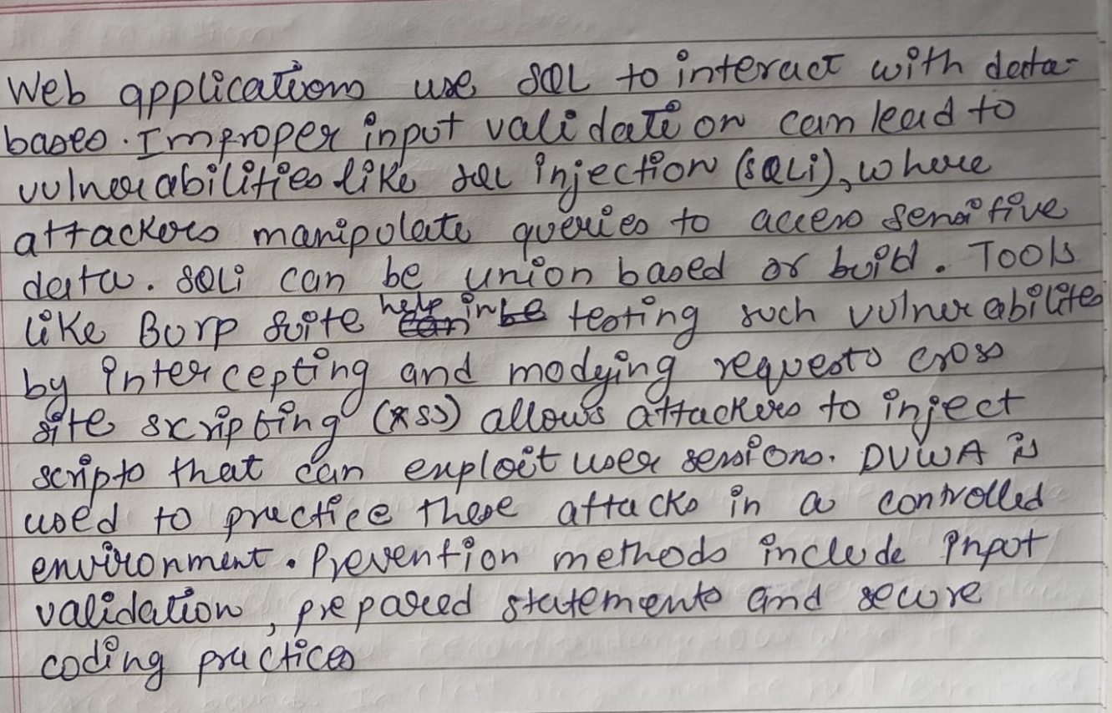
Implementation Details:
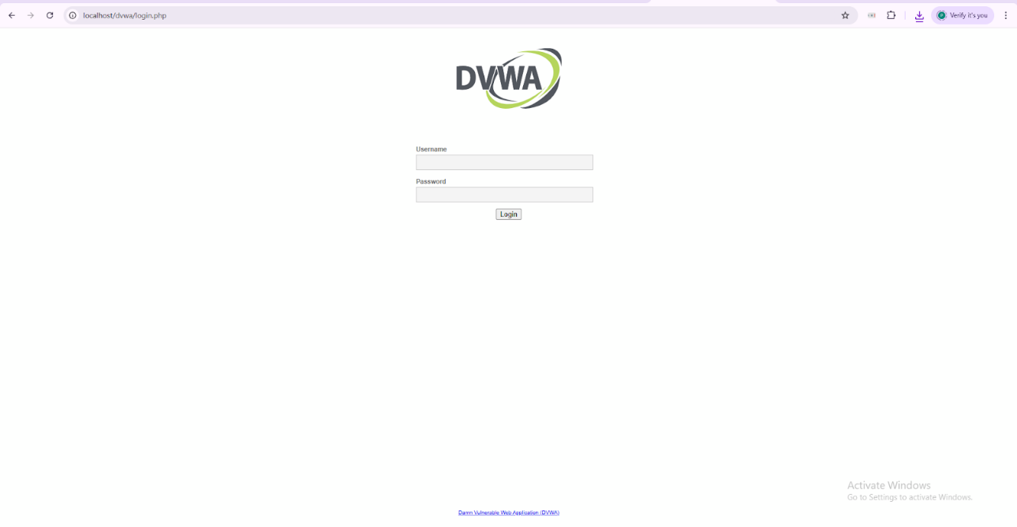
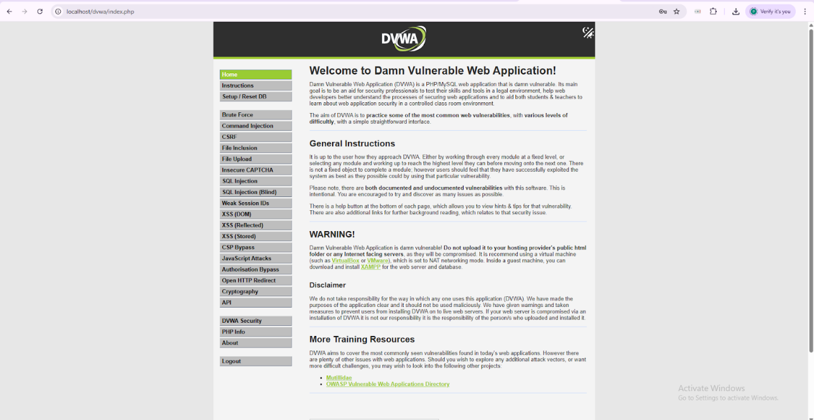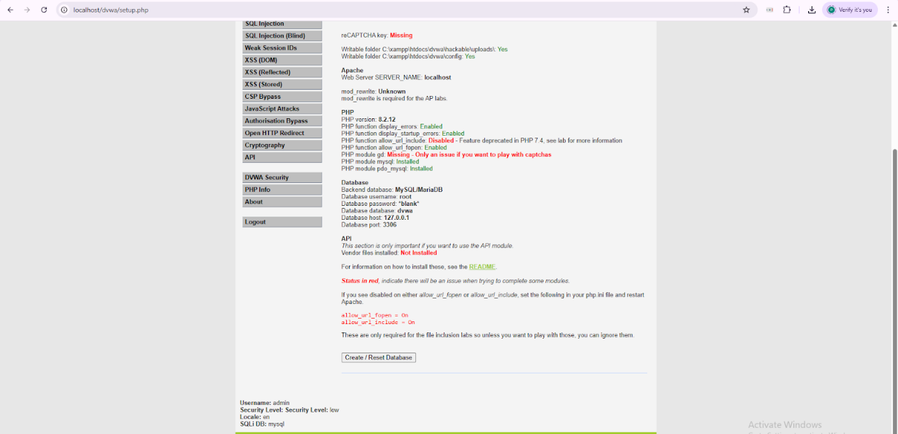
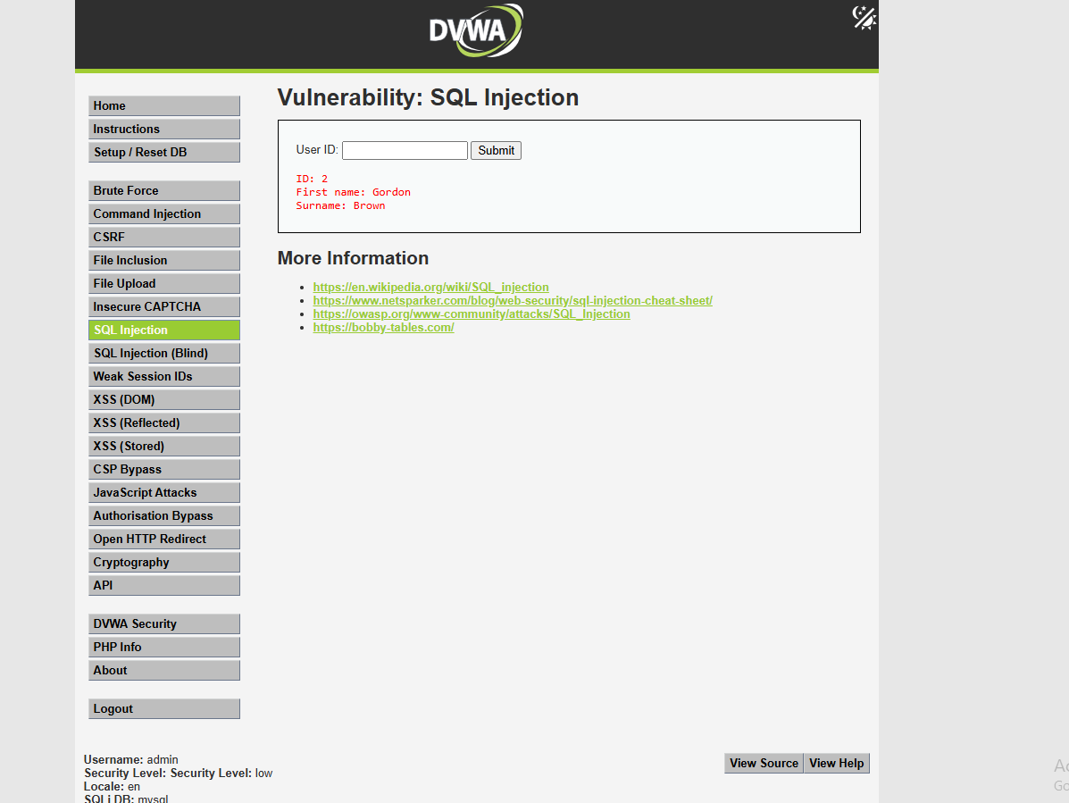
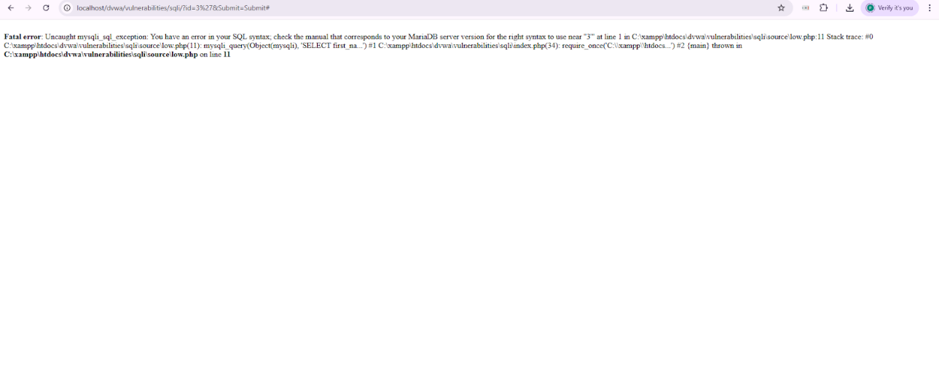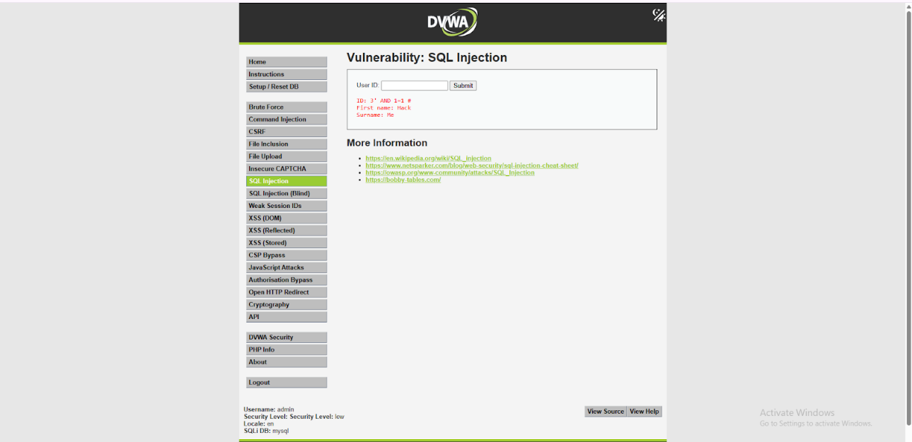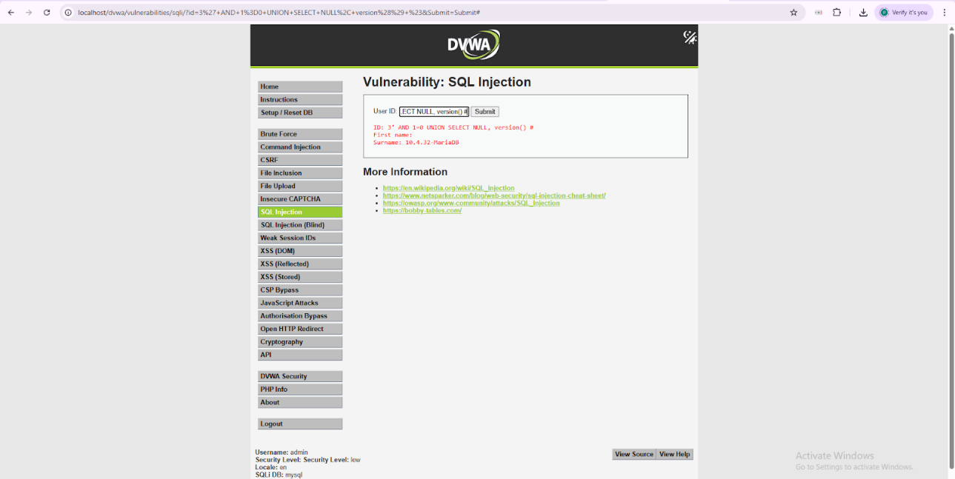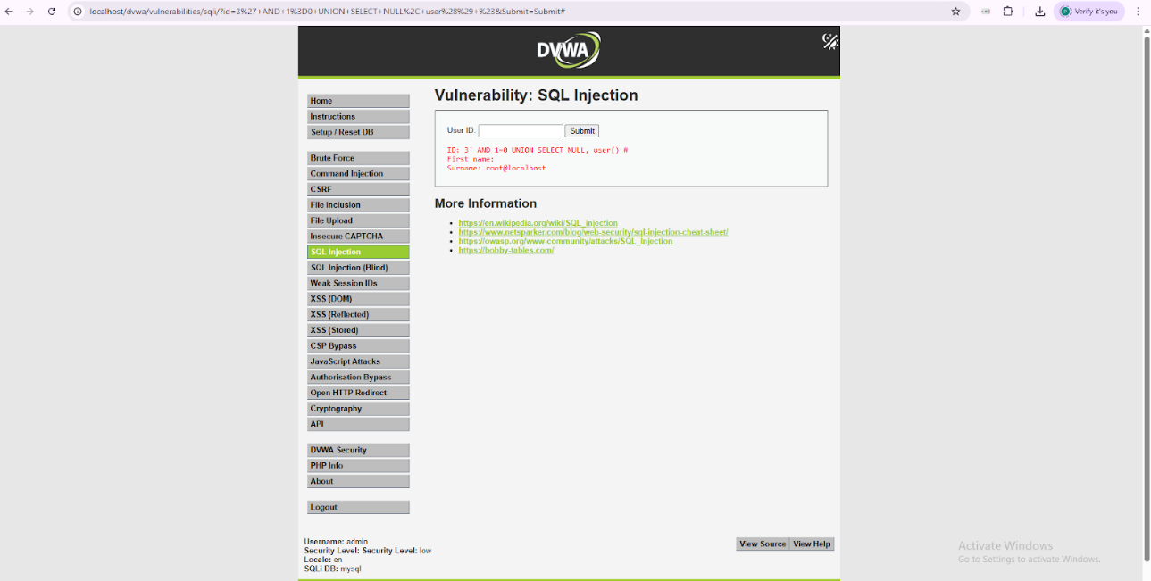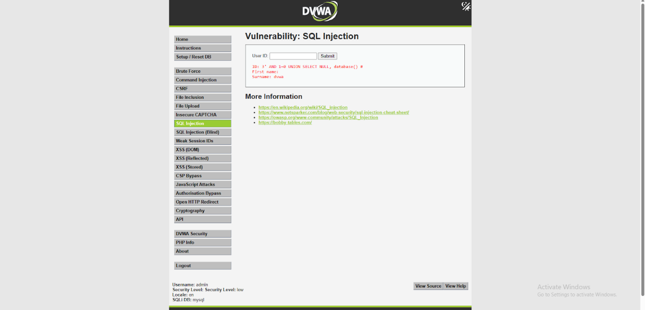
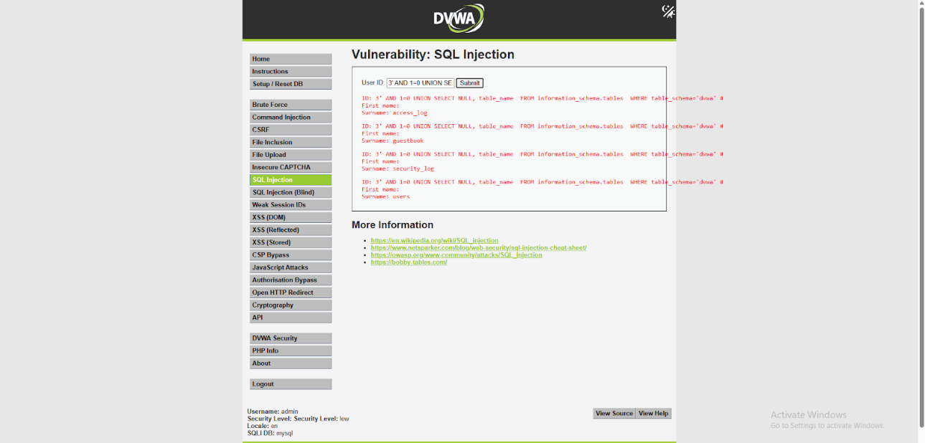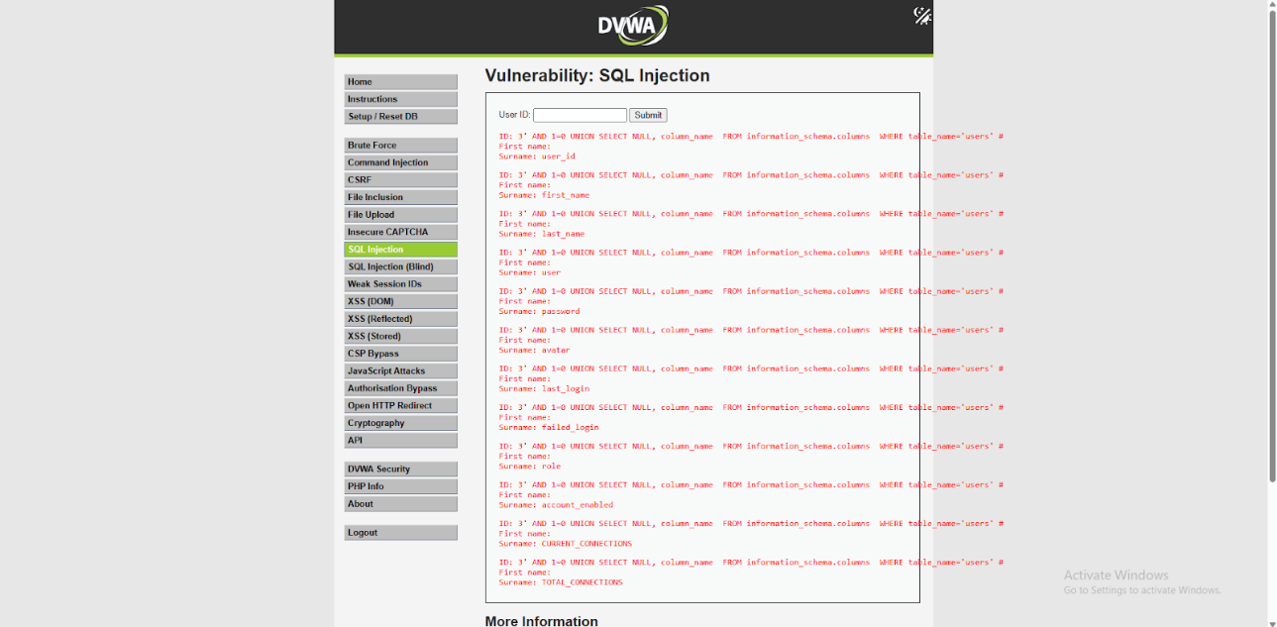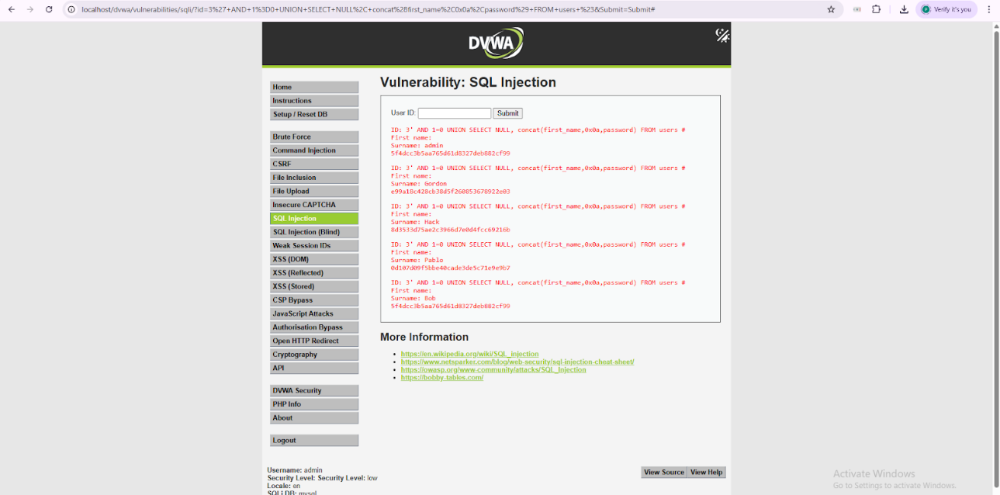
Results/Output:
Successfully accessed DVWA and configured the environment.
Confirmed SQL Injection vulnerability using error-based testing.
Conclusion:
In this experiment, DVWA was successfully configured and used to demonstrate SQL Injection vulnerabilities in a controlled environment. Manual SQL Injection techniques were applied to identify database weaknesses and extract sensitive information such as database details and user data. The experiment provided practical understanding of web application vulnerabilities and highlighted the importance of input validation and secure coding practices to prevent such attacks.
Post-Lab Questions:
1. Discuss role of following components of BURP Suite: Proxy, Intruder, Repeater, Decoder and Comparer.
- Proxy: Intercepts and modifies HTTP/HTTPS requests between browser and server.
- Intruder: Automates attacks like brute force and fuzzing by sending multiple payloads.
- Repeater: Allows manual modification and resending of requests for testing.
- Decoder: Encodes/decodes data (Base64, URL encoding, etc.) for analysis.
- Comparer: Compares two responses to identify differences in behavior or data.

2. Differentiate between Union-based and Blind SQL Injection.
Aspect | Union-based SQLi | Blind SQLi
Output visibility | Direct data displayed | No direct output
Method | Uses UNION SELECT | Uses true/false or time-based queries
Speed | Faster | Slower
Complexity | Easier | More complex

3. List the different validation techniques for prevention of SQLi.
- Use prepared statements / parameterized queries
- Input validation and sanitization
- Use stored procedures
- Limit database permissions
- Use ORM frameworks
- Escape special characters
- Implement Web Application Firewall (WAF)

4. XSS can lead to session hijacking even without stealing cookies directly. Justify the statement.
Yes. XSS allows execution of malicious scripts in the victim’s browser. Even without directly accessing cookies, attackers can perform actions on behalf of the user by:
- Sending authenticated requests (session riding)
- Redirecting users to malicious pages
- Modifying DOM content
- Capturing sensitive inputs

Thus, XSS can compromise sessions without explicitly stealing cookies.

